Autumn 2- Marvellous Me
How do we celebrate special occasions?
Themes, interests,  possible lines of enquiry |  | Autumn Halloween Bonfire Night Christmas Remembrance Day Children in Need    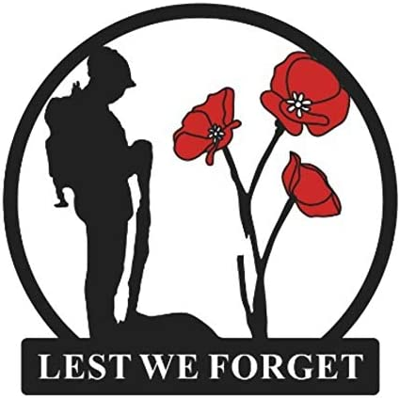  11th November  15th September      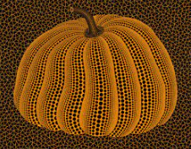  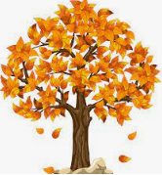
Suggested Texts | Themed Books | 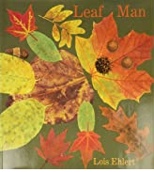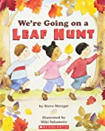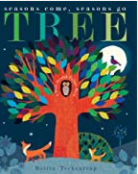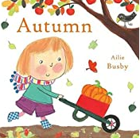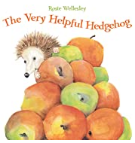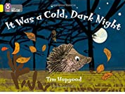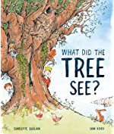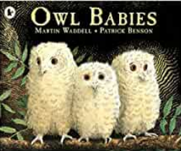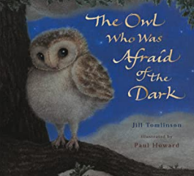  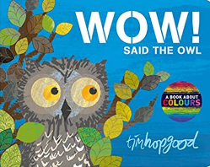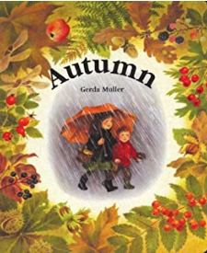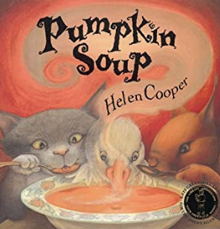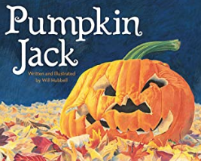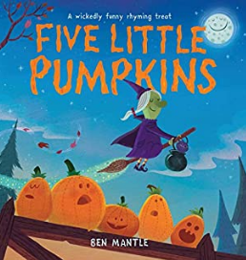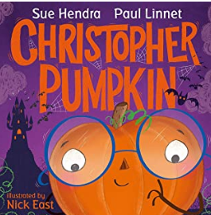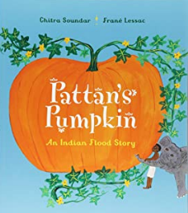  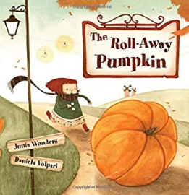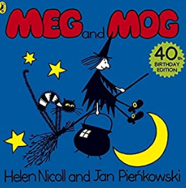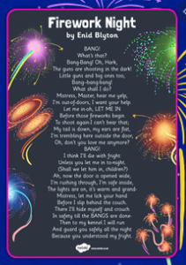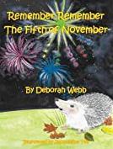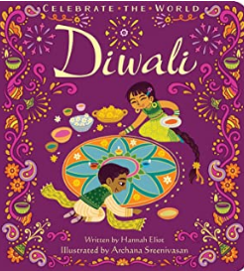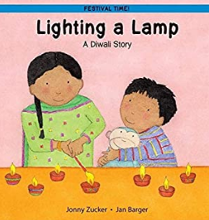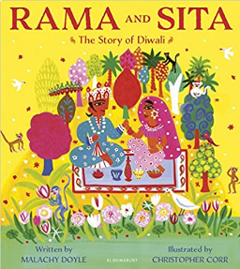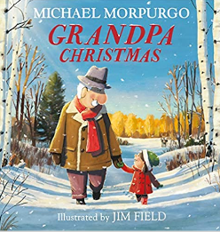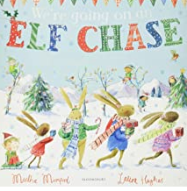  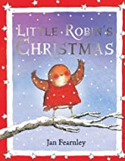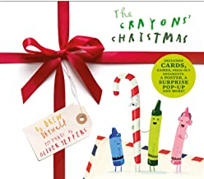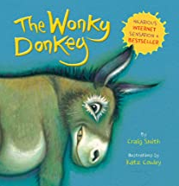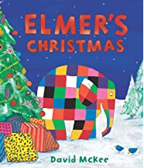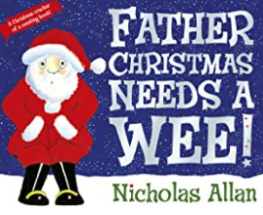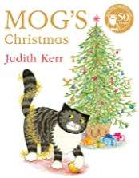
Suggested Texts | Autumn 2  Literacy texts | + Daily songs, nursery rhymes and poems  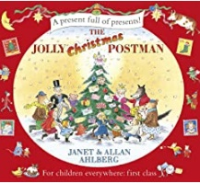  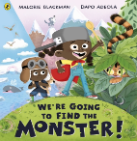  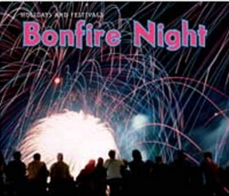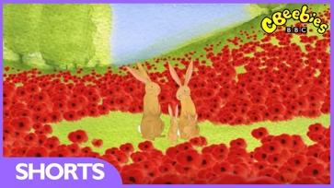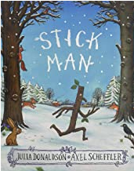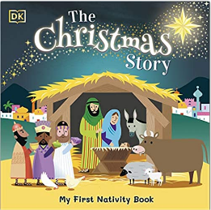

Area of learning | Knowledge and Skills (Know how, know that, know the) |  | Revisit/ongoing throughout the year
Communication and Language | Listening:  Listen in familiar and new situations.  Engage in stories that are familiar and new with interest and enjoyment.  Attention:  Maintain attention in new situations e.g., whole school assembly or PE sessions in the hall.  Shift attention when required e.g., when given a clear prompt - ‘name’.  Respond:  Make relevant comments when listening to a story and can answer ‘why’ questions.  Link events in a story to their own experiences.  Ask questions to find out more and to check they understand what has been said to them.  Respond to others appropriately in play.  Engage in story times.  Engage in non-fiction book.  Understanding:  Follow instructions or a question with 2 parts in familiar situations.  Speaking:  Use intonation to make meaning clear to others.  Start a conversation with peers and familiar adults and continue it for many turns.  Use simple conjunctions in talk to link thoughts ‘and’ ‘because’.  Retell a simple event e.g., how scratched knee’ Recognise words that rhyme or sound similar E.g., “Cat and hat”.  Develop social phrases – “Good morning, how are you?” |  | Learn new vocabulary  Use new vocabulary in different contexts.  Use new vocabulary through the day in discussions and conversations.  Learn new rhymes, poems, and songs.
Personal, Social  and Emotional Development | Express feelings:  Know how to show concern for others and show awareness of how their actions may impact on others.  Express their feelings and consider the feelings of others.  Manage behaviour:  Begin to take turns and share resources.  Can usually tolerate delay when needs are not immediately met.  Self-awareness:  Can talk about what they are doing and why.  Independence:  Know areas they would like to play in or resources they would like to use and independently access.  Know they can say when they help.  With some support, know how to get dressed and undressed for PE sessions.  Can follow instructions with 2 parts.  Collaboration:  Begin to share and take turns.  Social skills:  Continue to build constructive and respectful relationships.  Know familiar adults and peers to engage in conversations and ask for help.  JIGSAW lessons – Celebrating Difference  Covering acceptance, including others when playing, knowing how to help if someone is being bullied, problem solving, kind words, using compliments.  Books that can be used to support learning–  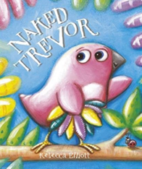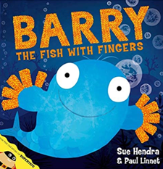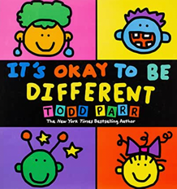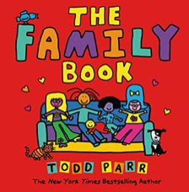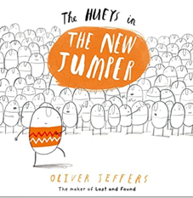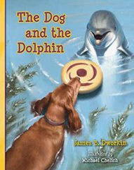 |  | Continue to develop skills of using gestures, non-verbal communication, facial expressions, body language, appropriate language, and vocabulary; to listen to others, speak to peers and adults and engage in discussions in a positive way.
Physical  Development | Revise and refine the fundamental movement skills they have already acquired: rolling, crawling, walking, jumping, running, hopping, skipping, climbing.  Develop their small motor skills so that they can use a range of tools competently, safely, and confidently. Suggested tools: pencils for drawing and writing, paintbrushes, scissors, knives, forks, and spoon. |  | Continue to develop core muscle strength to achieve a good posture when sitting at a table or sitting on the floor.
Physical  Development | Get set for PE  Ball Skills  Physical- Rolling a ball, stopping a rolling ball, throwing at a target, bouncing a ball, dribbling a ball with feet and kicking a ball.  Social- Co-operation and supporting others.  Emotional- Honesty and perseverance.  Thinking- Using tactics and decision making. |  | Continue to develop the overall body strength, co-ordination, balance, and agility needed to engage successfully with future physical education sessions and other physical disciplines including dance, gymnastics, sport, and swimming.
Literacy | COMPREHENSION  Engage in conversation and can answer questions when reading wordless fiction and nonfiction books.  Know how to respond to ‘who’, ‘where’ ‘what’ and ‘when’ questions linked to text and illustrations.  Know how to talk about events, feelings, main characters, where a story is set and recognise links to own life experiences. |  | Enjoy joining in with rhyme, songs, and poems (Christmas Poetry Basket)
Literacy | WORD READING  Read individual letters by saying the sounds for them.  Blend sounds into words, so that they can read short words made up of known letter-sound correspondences.  Read a few common exception words matched to our phonic programme. |  | Re-read books to build up confidence in word reading, fluency, understanding and enjoyment. Read books consistent with their phonic knowledge.
Literacy | WRITING  Emergent writing:  Copies adult writing behaviour e.g., writing on a whiteboard, writing messages.  Makes marks and drawings using increasing control.  Know there is a sound/symbol relationship.  Knows some recognisable letters and own symbols.  Write letters and strings, sometimes in clusters like words.  Composition:  Knows how to orally compose a sentence and hold it in memory before attempting to write it.  Spelling:  Knows how to orally spell VC and CVC words by identifying the sounds.  Knows how to write own name.  Handwriting:  Knows how to form letters from their name correctly.  Knows that after a word there is a space. |  | Develop listening and speaking skills in a range of contexts.
Phonics | Set 1  Know grapheme phoneme correspondence of 19 letters.  Know how to blend with known letters for reading VC and CVC words.  Know how to orally segment for VC and CVC words for spelling  Know high-frequency common words (the, to, no, go). |  | Continue to develop general sound discrimination, rhythm and rhyme, alliteration, voice sounds, oral blending, and segmenting.
Mathematics | Coverage- NCETM number blocks used | Ongoing Guidance
Mathematics | Representing 1-10  Know how to identify representations of numbers 1-10.  Know how to subitise or count to find out how many.  Know how to make their own collections.  Know how to match the number names we say to numerals and quantities. | Cardinality – know that the final number they say names the quantity of the set.  Correspondence – counting different arrangements by touching each object as they count.  Graphical representations – encourage own marking to represent numbers.
Mathematics | Comparing 1-10  Begin to know that as we count each number is one more than the one before.  Begin to know as we count back each number is one less than the previous number. | Use a range of representations to support understanding.  Support children to make comparisons in different contexts as they play.  Link to birthdays as children will soon be 5.
Mathematics | Composition of 1-10  Begin to know that all numbers are made up of smaller numbers. | Explore composition of larger numbers in play.
Mathematics | Formation of 1-10 | Numerals introduced but not expected to write them at this stage.
Mathematics | Circles and triangles  Know that circles have one curved side.  Know that triangles have three straight sides.  Know how to recognise these shapes on everyday items | Show a variety of different sized circles and triangles in different orientations and with sides of different lengths.
Mathematics | Positional language  Begin to know how to use positional language.  Begin to know how to represent real places they have visited with models, drawings, or maps. | Positional language describes how items are positioned in relation to other items.
Mathematics | One more one less  Begin to the know the link to between counting forwards and the one more pattern and counting backwards and the one less pattern. | Use books and rhymes to support one more one less e.g., gingerbread man, enormous turnip, hungry caterpillar, 5 little ducks, 5 speckled frogs.
Mathematics | Shapes with 4 sides  Know that squares and rectangles have 4 straight sides and 4 corners  Know how to recognise these shapes on everyday items | Show a variety of different sized squares and rectangles in a variety of different sizes and orientations.  NOTE: Squares are classed as special rectangles with 4 equal sides.
Mathematics | Time - Night and Day  Know how to order key events in daily routines.  Know language to describe when key events happen e.g., day, night, morning, afternoon, tomorrow, before, after.  Begin to know how to measure time in simple ways e.g., counting the number of sleeps to an important event, using timers to measure duration of events. | Link to the countdown to Christmas.
Understanding the World | 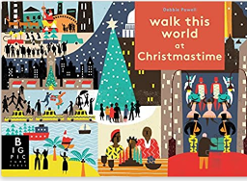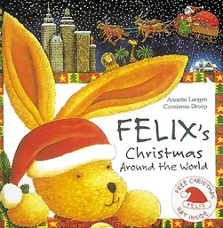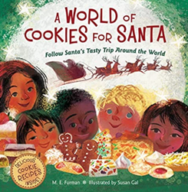
Understanding the World | Causation:  Begin to know that they can compare characters from stories to themselves and their own experiences.  Impact:  Know how to use the language of time when talking about past/present.  Chronology:  Begin to know how to use the language of time when talking about past/present events in their own lives and in the lives of others including people they have learnt about through books.  Enquiry:  Know about some key historical events – know why and how we celebrate today? Remembrance Day, Christmas Day, Diwali.  Respect:  Know that that people have different beliefs and celebrate special times in different ways.  Begin to know some similarities and differences between life in this country and life in other countries.  Mapping:  Know how to use technology in exploring mapping - a Bee Bot and begin to show spatial awareness. Use positional language i.e., under, beside, on top of etc.  Communication:  Know that the environment where they live can change through the seasons. Describe what they see, hear, and feel outside.  Explore the natural world around them by taking part in weekly forest school inspired ‘Nature School’ sessions.  RE (NYCC)– Which people are special and why?  Coverage – talking about people who are special to them, what makes their family and friends special to them, identifying some of the qualities of a good friend, talking about stories of Jesus as a friend to others , learning about a special person in Sikhism and talk about what can be learnt from it.
Expressive Arts and Design | Mark Making/Drawing:  Skill: observational drawing - Pumpkins  Know how to create closed shapes with continuous lines and begin to use these shapes to represent objects.  Colour:  Recognise and name colours.  Painting:  Explore that there are different paint types - watercolour, powder paint, acrylic, ready mix paint.  Sculpture and Natural Art:  Andy Goldsworthy inspired nature art using autumnal objects such as conkers, acorns and leaves that have changed colours  Materials:  Know how to use different materials for Junk modelling. Junk modelling will continue to be offered in continuous  provision.  3D Work:  Know how to use simple joins when using different materials to create 3D work, e.g., Sellotape, masking tape,  stick glue.  Cutting Skills:  Know how to use scissors to cut in a straight line.  Songs and Rhyme Knowledge  Christmas Poetry Basket Songs:  Know the following songs –  I’m a little elf  In My Christmas Den  Out of the Corner of My Eye  Robin is my name  Whether the weather  World Nursery Rhyme Week:  The Big Ship Sails  12345 (Once I Caught A Fish Alive)  Five Little Speckled Frogs  BINGO  Twinkle, Twinkle |  | Ongoing  Explore, use, and refine a variety of artistic effects to express their ideas and feelings.  Take part in simple, pretend play often based on familiar experiences, e.g., making dinner.  Uses available resources to create props or creates imaginary ones to support play.  Develop storylines through small-world or role-play

